SUGGESTION FOR 2 WEEKS (indicative only)
RAIATEA – TAHA’A- HUAHINE- BORA-BORA RAIATEA
Restaurants and excursions are indicative and optional, and list is not exhaustive.
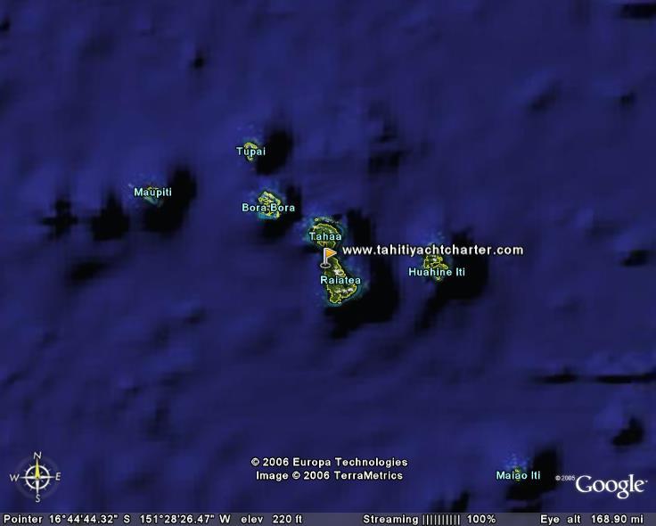
Day 1 : RAIATEA-TAHA’A.(1h1/2 sailing in inner lagoon)Welcome at the airport and transfer to the Marina Apooiti to the Tahiti Yacht Charter base
Program and chart studies, suggestion of programs. Sailing to motu Mahaea/Ceran to spend the afternoon. Swimming, kayaks, snorkelling near the reef
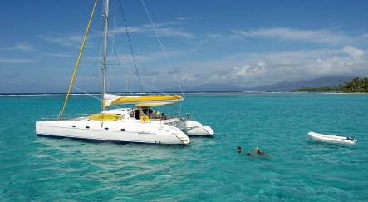
Copyright P.Lefebvre
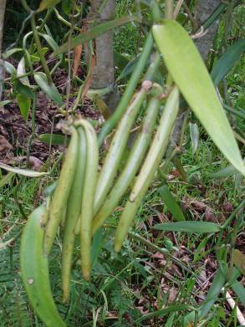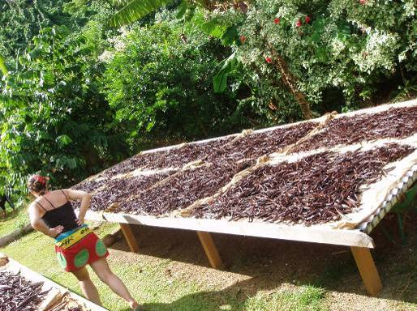
Free visit of a vanilla plantation, near Motu Pearl village – possibility to buy first quality vanilla beans
Day 2 : TAHA’A-HUAHINE (3 to 4 hours of navigation) Depart for Huahine mooring near the village of Fare. Visit of the village, the house of the handicraft, the mammas and their fruit booth.
Sail to Avea beach, beautiful white sand beach. Swimming, snorkelling, kayaks. Possible dinner (not included in price, au relais Mahana + 689 60 60 40–polynesian food or pension Mauarii + 689 68 86 49 , Crab and lobster dinner
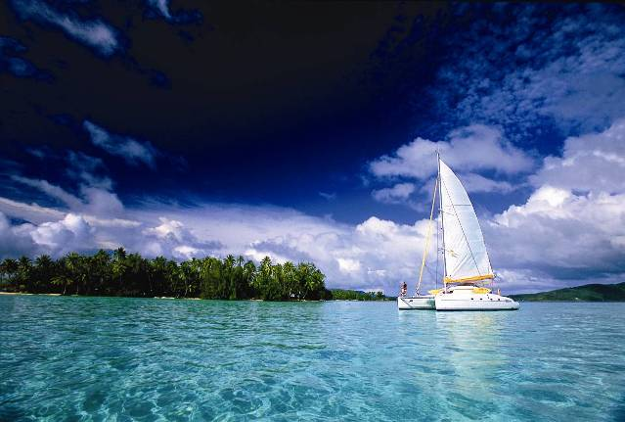
Copyright David Kirkland
Day 3 : LAGOON OF HUAHINE.
Possible excursion (paying option) tour the island in 4 wheel drive, half day : sacred « blue eyed” eels , « Marae », archeological temple, site seeing, fish traps, with Huahine Land –
tel + 689 68 89 21/78 58 31 (more flavour than just renting your own car to tour the island, ask your guide to find some fresh crabs, lobsters with the local inhabitants, payment in cash CFP)
Day 4 : HUAHINE
Visit of the village of Parea in dinghy.
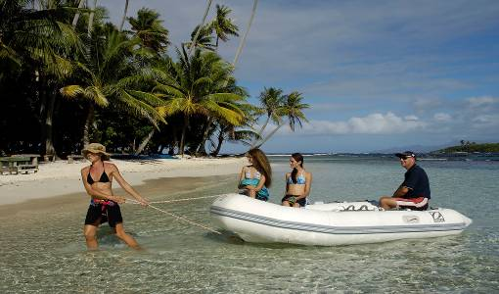
Sailing to Port Bourayne. Explore the bay of Maroe in dinghy
Swimming, snorkelling, kayaks, return to the village of Fare,
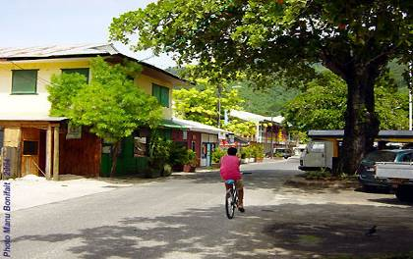
Bank, ATM machine, shopping, internet, laundry at Huahine Nautique, fuel and water refill at the dock, night mooring between the pass and the beach. Possible dinner at Restaurant Te Marara tel + 689 68 70 81, local band on Wednesday, Friday and saturday.
Day 5 : HUAHINE- TAHA’A (3 to 4 hours sailing)
Sailing to motu TauTau (le Taha’a-relais&château)
exploration and snorkelling thru the coral garden. Superb sunset on Bora-Bora.
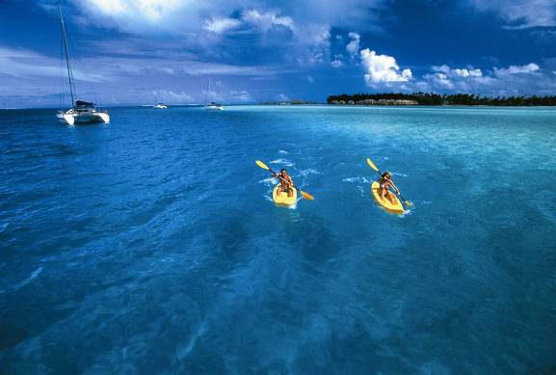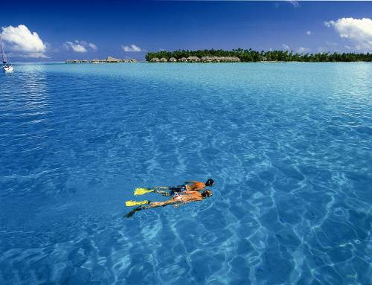
Copyright David Kirkland
Day 6 : LAGOON OF TAHA’A. mooring in Hurepiti bay
On option (non included), visit of a vanilla farm, see how the flowers are « married », Vanilla Tour, Alain Plantier, + 689 65 62 46, VHF 9 this is a more complete tour than the FOC visit of day 1
or visit of a black pearl farm in Apu Bay (free of charge).

Day 7 : RAIATEA-BORA-BORA. (3 to 4 hours of navigation, fishing along the way),
Sailing towards Bora-Bora, enter by the majestuous pass of TEAVANUI. Mooring near motu Topua- the bells of Hiro (Tahitian god and hero).


Copyright. Benjamin Picard
Nautical activities : kayaking, swimming snorkelling
Sail to Pofai bay, visit the village of Vaitape –boutiques, shopping
Dinner (not included in price) at the Bloody Mary’s Catch of the day. Not to be missed
Night mooring
Day 8 : LAGOON OF BORA-BORA.
Sail the road of the motus (small islets)
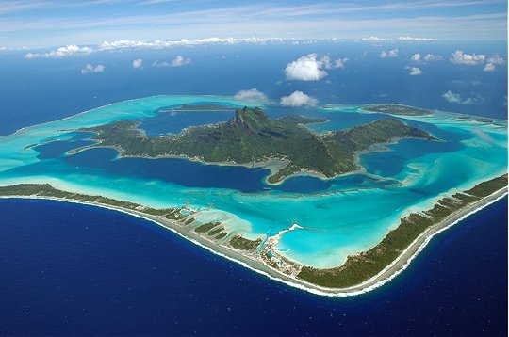
Paying option, Visit of the lagoonarium , natural aquarium where you will see sharks, turtles, manta rays, fish…
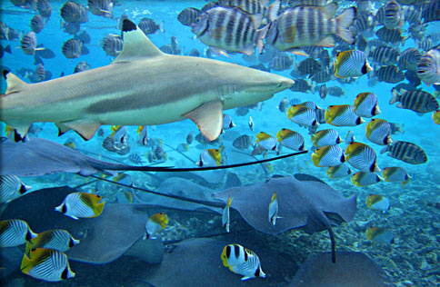

Day 9 : LAGOON OF BORA-BORA
Sailing towards the motu Piti (close to Matira Point), nice snorkelling spot
Copyright David Kirkland
Paying option, The fabulous Deep Ocean where the water is taken from 850 meters depth.
Deep Ocean Spa - Intercontinental Resort&Thalasso-Spa Bora-Bora.
http://www.deepoceanspa.com
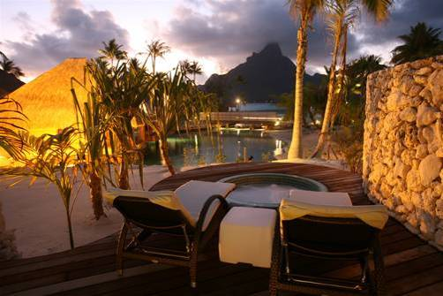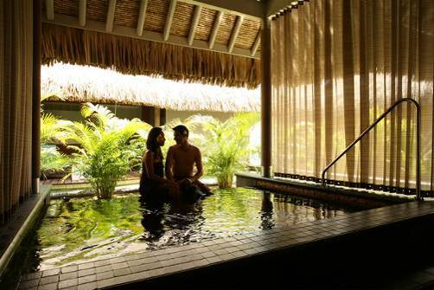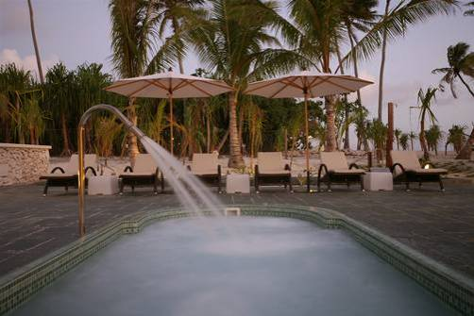
Booking mandatory tel + 689 607 700. Correct attire at all time, this is 5 stars hotel
Be sure to go ½ hour before your massage- we recommend the Polynesian Monoi Massage
And feel free to spend extra time at the Spa, after your massage, trying the perfumed rain showers, the cold water basin etc…
Other Spa options, facials, massages on the menu aboard.

Sail back to the Bora-Bora yacht club, facing the Teavanui pass. Mooring buoys, water refill, restaurant on premises
Day 10 : BORA-BORA-RAIATEA (about 5 hours of sailing). Sailing towards the town of Uturoa, visit of the city, the market, bank, ATM machine shopping, internet
Day 11 : Sail to Faaroa Bay
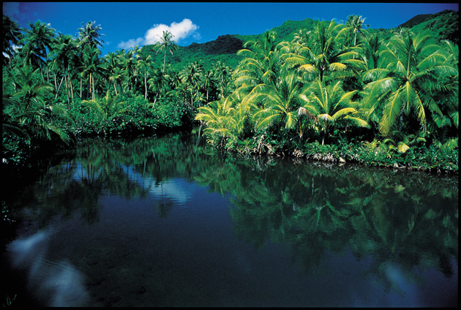
Explore the river by dinghy

In the afternoon, the yellow flowers of the « purau tree» end their short life by a gracious plundge in the river.

Day 12 : RAIATEA
sailing to Opoa Bay
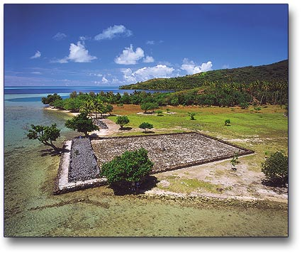
Visit of the Marae Taputapuatea, considered as the departure point of the Polynesian migration (under classification of Unesco worl heritage)
Navigation towards the motu Nao Nao
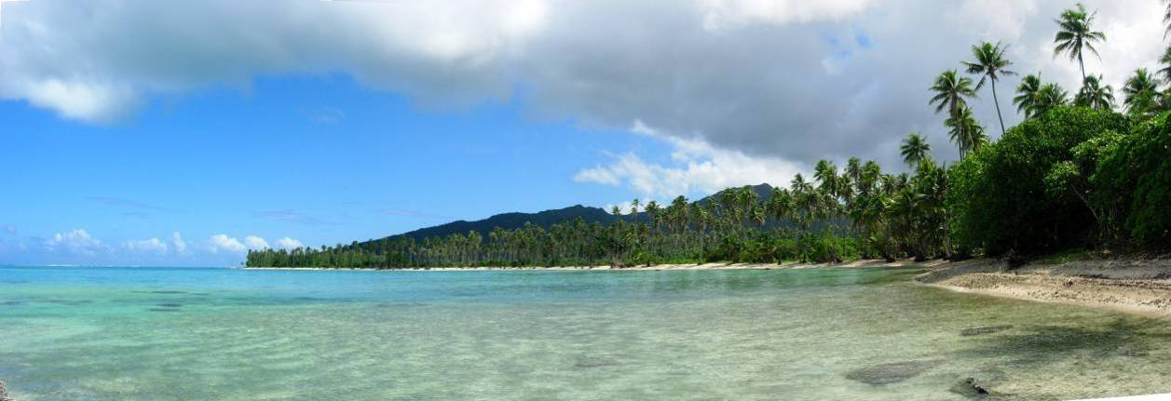
Nautical activities : kayak, swimming, snorkelling, very often you will see rays
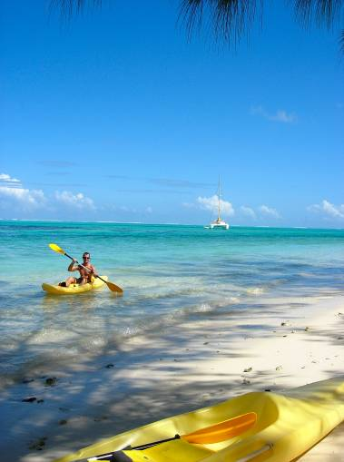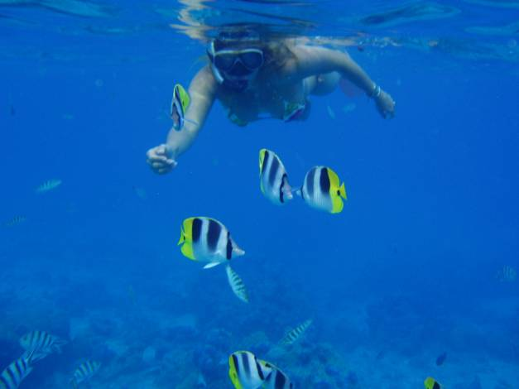
Dinner aboard, night mooring

Day 13 : RAIATEA-

Stay at motu Nao Nao

Day 14 RAIATEA
If you have not yet visited a pearl farm, Anapa Pearl is on your way. Here you can snorkel and watch the mothers of the pearl
Sail to Miri Miri motu, nice snorkelling spot

Day 15 RAIATEA

Last sail
And disembarkment at our base, marina Apooiti

There are many diving spots on each island visited. Diving pass are proposed at our base and at any diving club along the way.

